BIOGRAPHY MR. ROGERS
A True Friend and a Truly Friendly Person
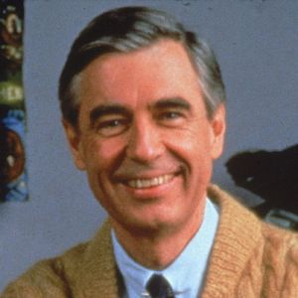
Anyone who does anything to help a child
in his life is a hero to me.
Fred Rogers
And Mr. Rogers certainly was friendly and a friend to all in his TV audience. Mr. Rogers got into TV because the first time he saw a children's TV show it had “something horrible on it with people throwing pies at one another…” He stated, “I went into television because I hated it so, and I thought there was some way of using this fabulous instrument to be of nurture to those who would watch and listen.” That is to befriend the children. He decide from the beginning, that his show would be unlike most children’s shows. Visually, the presentation of the show would be very simple, and it did not feature the animation or fast pace of other children's shows, which Rogers thought of as "bombardment". He, Mr. Rogers would play himself not just in name, but also in personality and mannerisms, changing nothing about how he acted off camera to how he acted on camera. His reasons for this were that: “One of the greatest gifts you can give anybody is the gift of your honest self. I also believe that kids can spot a phony a mile away.”
Rogers was awarded the Presidential Medal of Freedom in 2002, for his contributions to children's education, justified by President George W. Bush, who said, "Fred Rogers has proven that television can soothe the soul and nurture the spirit and teach the very young".
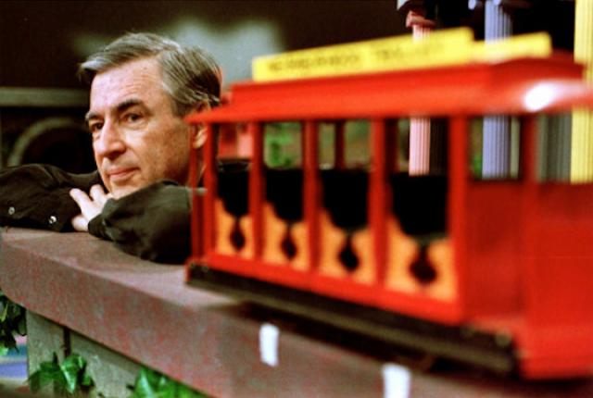
Mister Rogers' Neighborhood won four Emmy awards, and Rogers himself was presented with a Lifetime Achievement Award at the 1997 Daytime Emmys, as described by Esquire's Tom Junod:
Mister Rogers went onstage to accept the award—and there, in front of all the soap opera stars and talk show sinceratrons, in front of all the jutting man-tanned jaws and jutting saltwater bosoms, he made his small bow and said into the microphone, "All of us have special ones who have loved us into being. Would you just take, along with me, ten seconds to think of the people who have helped you become who you are. Ten seconds of silence."
And then he lifted his wrist, looked at the audience, looked at his watch, and said, "I'll watch the time." There was, at first, a small whoop from the crowd, a giddy, strangled hiccup of laughter, as people realized that he wasn't kidding, that Mister Rogers was not some convenient eunuch, but rather a man, an authority figure who actually expected them to do what he asked. And so they did. One second, two seconds, three seconds—and now the jaws clenched, and the bosoms heaved, and the mascara ran, and the tears fell upon the beglittered gathering like rain leaking down a crystal chandelier. And Mister Rogers finally looked up from his watch and said softly "May God be with you," to all his vanquished children.
To see this on You Tube, click the picture –
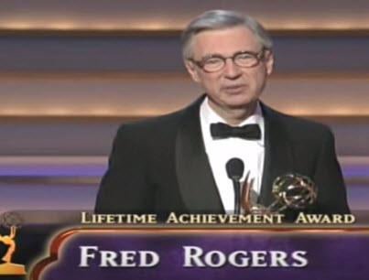
Link - https://www.youtube.com/watch?v=Upm9LnuCBUM
Mr. Rogers had episodes about friends, friendships, being friendly, such as –
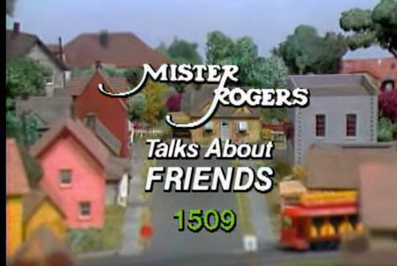
Link - https://www.youtube.com/watch?v=7ZJY6yf0uLY
I, also, found on You Tube -
Mister Rogers' Neighborhood Friends
Mister Rogers' Neighborhood Friends 1509
You are my friend you are special Mr Rogers
Mister Rogers' Neighborhood 22x08 Imaginary Friends part 3
Mr. Rogers "You are my Friend, You are Special"
Mister Rogers - Friends often have hard times
Mister Rogers - It's good to talk with your friends when you are angry
"Mister Rogers' ASL Friends"
And with some more searching I am sure you can find others.
For a deeper look at Fred Rogers, watch the clip of him on the Tonight Show –
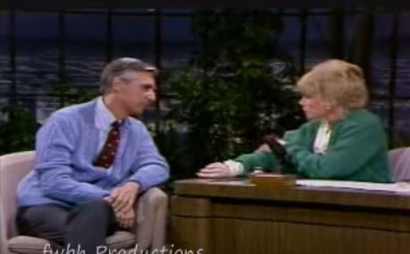
Link - https://www.youtube.com/watch?v=p-Kp5YeqrlE

Mr Rogers Quotations
The greatest gift you ever give
is your honest self.
Forgiveness is a strange thing. It can sometimes be easier to forgive our enemies than our friends. It can be hardest of all to forgive people we love. Like all of life's important coping skills, the ability to forgive and the capacity to let go of resentments most likely take root very early in our lives.
When I say it's you I like, I'm talking about that part of you that knows that life is far more than anything you can ever see or hear or touch. That deep part of you that allows you to stand for those things without which humankind cannot survive. Love that conquers hate, peace that rises triumphant over war, and justice that proves more powerful than greed.
When I say it's you I like, I'm talking about that part of you that knows that life is far more than anything you can ever see or hear or touch. That deep part of you that allows you to stand for those things without which humankind cannot survive. Love that conquers hate, peace that rises triumphant over war, and justice that proves more powerful than greed.
Love isn't a state of perfect caring. It is an active noun like struggle. To love someone is to strive to accept that person exactly the way he or she is, right here and now.
Anything that’s human is mentionable, and anything that is mentionable can be more manageable. When we can talk about our feelings, they become less overwhelming, less upsetting, and less scary. The people we trust with that important talk can help us know that we are not alone.
Mutual caring relationships require kindness and patience, tolerance, optimism, joy in the other's achievements, confidence in oneself, and the ability to give without undue thought of gain.
Whether we're a preschooler or a young teen, a graduating college senior or a retired person, we human beings all want to know that we're acceptable, that our being alive somehow makes a difference in the lives of others.
We need to help people to discover the true meaning of love. Love is generally confused with dependence. Those of us who have grown in true love know that we can love only in proportion to our capacity for independence.
Who we are in the present includes who we were in the past.
The child is in me still and sometimes not so still.

OTHER FRIENDLY "PEOPLE"
I had trouble finding a person a highlight this month for "Friendly." It appears that attribute is not cited too often. My wife suggested,
"Casper, the Friendly Ghost."
And I said maybe, but I prefer a real person. But I did find Casper in "Boo Scout" on line. He is very friendly but when watching remember this video is from 1951 and somethings have changed.
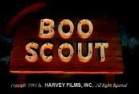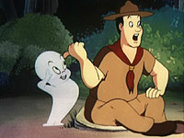
The link - https://www.youtube.com/watch?v=T-ThhkmrMe8 If you Google for Boo Scout it is on You Tube more than once.
I checked for "Friendliest Athletes," and found various lists like – "5 Favorite Good-Guy Pro Athletes," (http://www.yourtango.com/201070181/5-favorite-good-guy-pro-athletes/page/1/ ) by Sara Brady which lists Drew Brees, Scott Fujita, LeBron James, Roger Federer, and Ray Allen. Other lists I found have Venus Williams and lots of other athletes. All great athletes and all donating money to foundations doing good for people. But the word friendly did not appear.
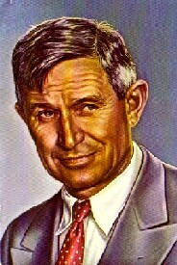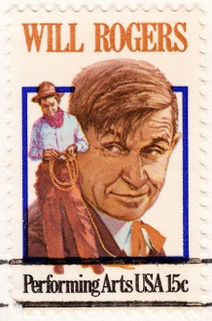
I thought about Will Rogers ("I never met a man I didn't like") but I had featured him in Baloo's Bugle recently. Go to the Positive Attitude issue from 2011-2012 Scouting Year.
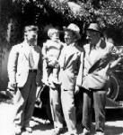

Will Rogers, Wiley Post and Waite Phillips at Villa de Philmonte

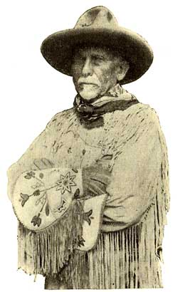
And Daniel Carter Beard (Uncle Dan, the first National Commissioner of the BSA) who was featured in a Boys' Life article titled, "The Friend of Youth." He is the only one of the founding fathers of the BSA (James E West, Ernest Thompson Seton, William D Boyce) usually shone pictured with youth. If you want to read the article, go to http://boyslife.org, and click on the archives, or Wayback Machine, and look up the 1925 article. I will feature him in a future issue.
Then I talked (actually texted) with my daughter and her friend Kelly and they suggested, Mr. Rogers. Whom you already know I chose to feature.

